PROJECT

**FRONT END DEVELOPMENT**

Ecommerce-Shoe Store



Department Of Electronics and Communication Engineering

ADITYA COLLEGE OF ENGINEERING

Approved by AICTE, Permanently Affiliated to JNTUK & Accredited by NAAC

Recognized by UGC under the sections 2(f) and 12(B) of the UGC act 1956.

Aditya Nagar, ADB Road – Surampalem 533437, E.G. Dist., A.P.,

2022-2023.

**Under guidance of Submitted by:**

K. Chandra Sekhar sir J.V.S.S.J.MANIKANTA

Y.D.C. YOGESH

E.V. ARAVIND

K. VEERENDRA

TABLE OF CONTENTS

* Acknowledgement
* Abstract

**CHAPTER-1: - INTRODUCTION**

1.1 Overview

1.2 Purpose

**CHAPTER-2: - LITERATURE SURVEY**

2.1 Existing problem

2.2 Proposed solution

**CHAPTER-3: - THEORITICAL ANALYSIS**

3.1 Block diagram.

3.2 Hardware / Software designing.

**CHAPTER-4: - RESULT**

**CHAPTER-5: - ADVANTAGES & DISADVANTAGES**

**CHAPTER-6: - APPLICATIONS**

**CHAPTER-7: - CONCLUSION**

**Acknowledgement**

First, I would like to thank the Directors of Smart Internz and Smart Bridge Hyderabad for giving me the opportunity to do an internship within your organizations.

It is with immense pleasure that we would like to express our indebted gratitude to our Faculty Mentor Mr. Kotikalapudi Chandra Sekhar who has guided us a lot and encouraged us in every step of the intern project work, her valuable moral support and guidance throughout the Intern project helped us to a greater extent.

**Abstract: -**

The Ecommerce Shoe Store Website project presents a comprehensive online platform designed to redefine the shoe shopping experience. This document outlines the development of a user-centric website that offers a wide range of footwear choices while addressing challenges associated with traditional shoe shopping and online purchasing. The website provides detailed product information, size guides, secure payment gateways, and account management features to create a seamless and secure shopping journey.

The project encompasses an in-depth analysis of the challenges and existing solutions in the retail and ecommerce sectors. It presents a theoretical framework and technical architecture for the website's implementation, including hardware and software requirements. The outcome is a functional website that enables customers to explore, select, and purchase shoes while enjoying the convenience of online shopping.

The documentation further discusses the advantages and disadvantages of the proposed solution, outlining potential applications and the project's implications for the future of online retail. It underscores the significance of user-centricdesign, secure payment systems, and continuous innovation in shaping the ecommerce landscape. Through its development, the project showcases the potential for technology to transform consumer behaviours and elevate the shopping experience.

**CHAPTER -1: - INTRODUCTION**

**1.1 Overview**

The Ecommerce Shoe Store Website is a sophisticated online platform aimed at revolutionizing the way customers purchase footwear. It provides an extensive collection of shoes, ranging from athletic to formal, catering to diverse customer preferences. With an intuitive user interface, secure payment gateways, and comprehensive product information, the website strives to offer an unparalleled shopping experience.

**1.2 Purpose**

The primary objective of this project is to bridge the gap between traditional shoe shopping and the digital age. By providing an accessible and user-friendly website, the project aims to enable customers to explore, compare, and purchase shoes from the comfort of their homes. The website's purpose is to simplify the shopping process, enhance customer satisfaction, and ultimately drive sales.

**CHAPTER-2: - LITERATURE SURVEY**

**2.1 Existing Problem**

The conventional shoe shopping experience often involves limited product availability, time-consuming visits to physical stores, and the inability to thoroughly evaluate product details. Online shoe shopping introduces challenges related to sizing accuracy, product quality perception, and concerns about payment security.

**2.2 Proposed Solution**

The proposed solution tackles these issues by offering a comprehensive online shoe shopping platform. The website integrates advanced size guides, high-resolution product images, and detailed descriptions, addressing concerns related to size accuracy and product quality. Secure payment gateways are implemented to in still trust and ensure safe transactions.

**CHAPTER -3: - THEORETICAL ANALYSIS**

**3.1 Block Diagram**

The block diagram illustrates the interconnected components of the Ecommerce Shoe Store Website:

The user interface provides easy navigation through the product catalogue. Customers can select products, view details, and add them to the shopping cart. The payment processing component ensures secure transactions, leading to successful order fulfilment.

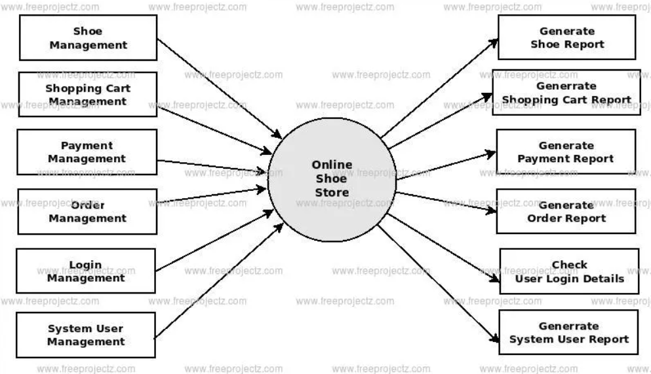

**3.2 Hardware / Software Designing**

**Hardware Requirements:**

A dedicated web server to host the website and handle user requests.

A separate database server to manage product information, customer data, and orders securely.

Integration with reliable payment gateways to facilitate secure transactions.

**Software Requirements:**

Front-end development tools such as HTML, CSS, and JavaScript for creating an engaging user interface.

**HTML:** - HTML is the standard markup language used to create the structure and content of web pages. It consists of a series of elements, which are represented by tags, that define the structure and semantics of the content on a webpage. HTML is the foundation of any web page, providing the essential structure for text, images, links, forms, and more.

**CSS:** - CSS is a stylesheet language used to control the visual appearance of HTML elements on a web page. It allows you to define colours, fonts, spacing, layout, and other visualproperties of elements. CSS enables the separation of content and presentation, making it easier to maintain and update the look and feel of a website across multiple pages.

**JAVASCRIPT: -** JavaScript is a versatile programming language primarily used for creating dynamic and interactive elements on web pages. It runs in the browser and enables functionalities like form validation, animations, interactive user interfaces, and asynchronous operations (AJAX). JavaScript allows developers to add behaviour and interactivity to static HTML and CSS.

**BOOTSTRAP: -** Bootstrap is a popular open-source front-end framework that provides a set of pre-designed, responsive, and customizable components and styles. It's built on HTML, CSS, and JavaScript and aims to simplify and accelerate the process of creating consistent, modern, and responsive web designs. Bootstrap offers a grid system, typography, navigation components, modals, forms, and more, making it a powerful tool for web development.

**CHAPTER-4: - RESULT**

The Ecommerce Shoe Store Website project culminates in a fully operational website that addresses customer needs and concerns. Some notable features and outcomes include:

A visually appealing and responsive user interface, ensuring seamless navigation across devices.

Detailed product pages with high-resolution images, comprehensive descriptions, and customer reviews.

An intuitive shopping cart that allows users to review their selections and adjust quantities.

Integration of secure payment gateways, offering multiple payment options for customer convenience.

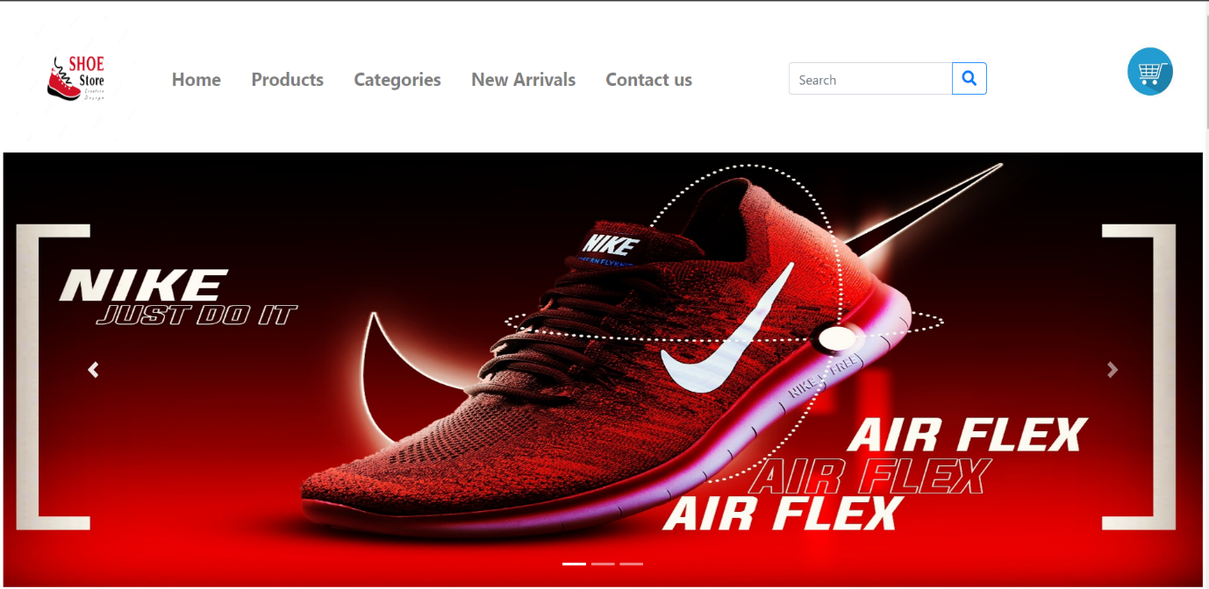Order confirmation emails containing essential details and tracking information. User account creation and management, enabling customers to track orders and update their profiles.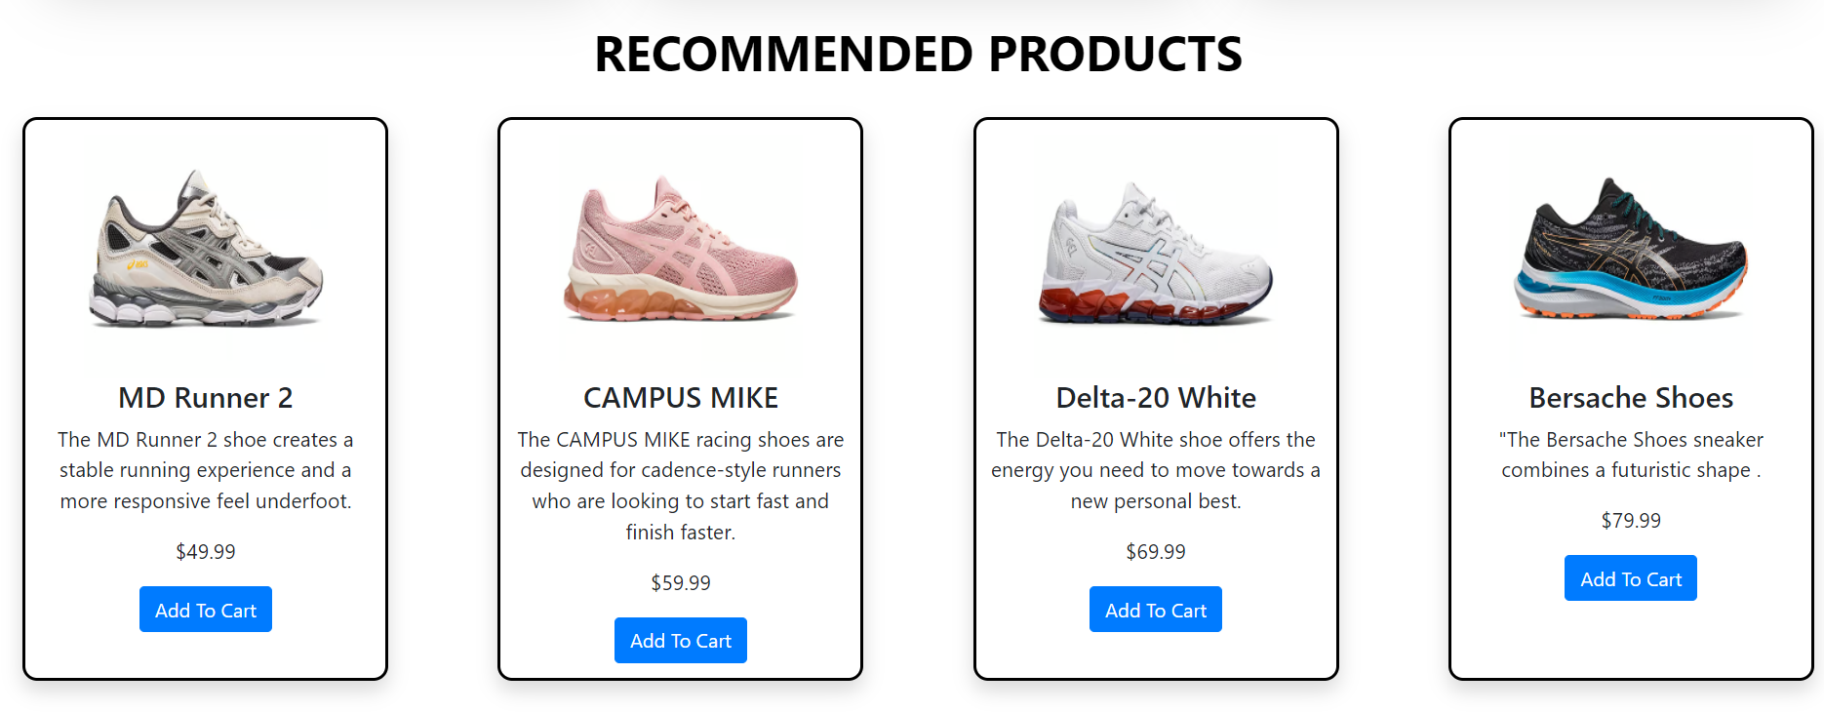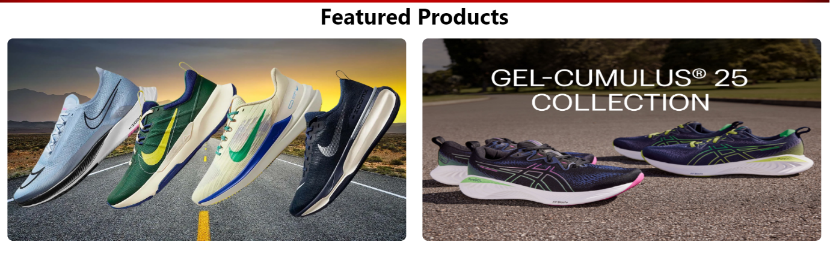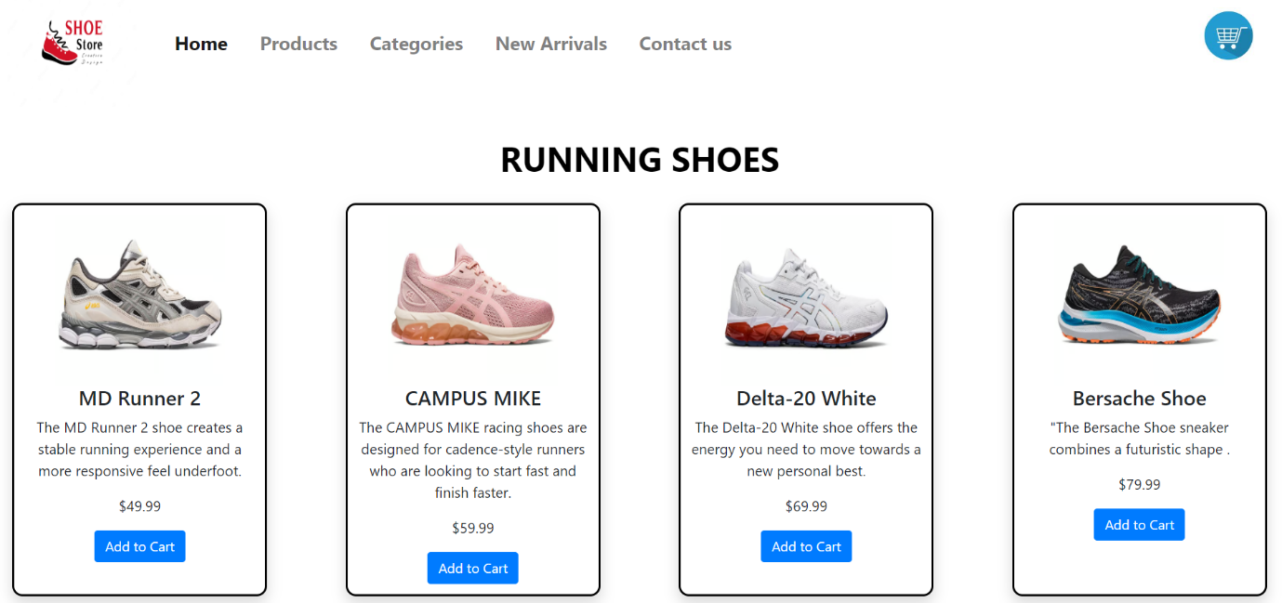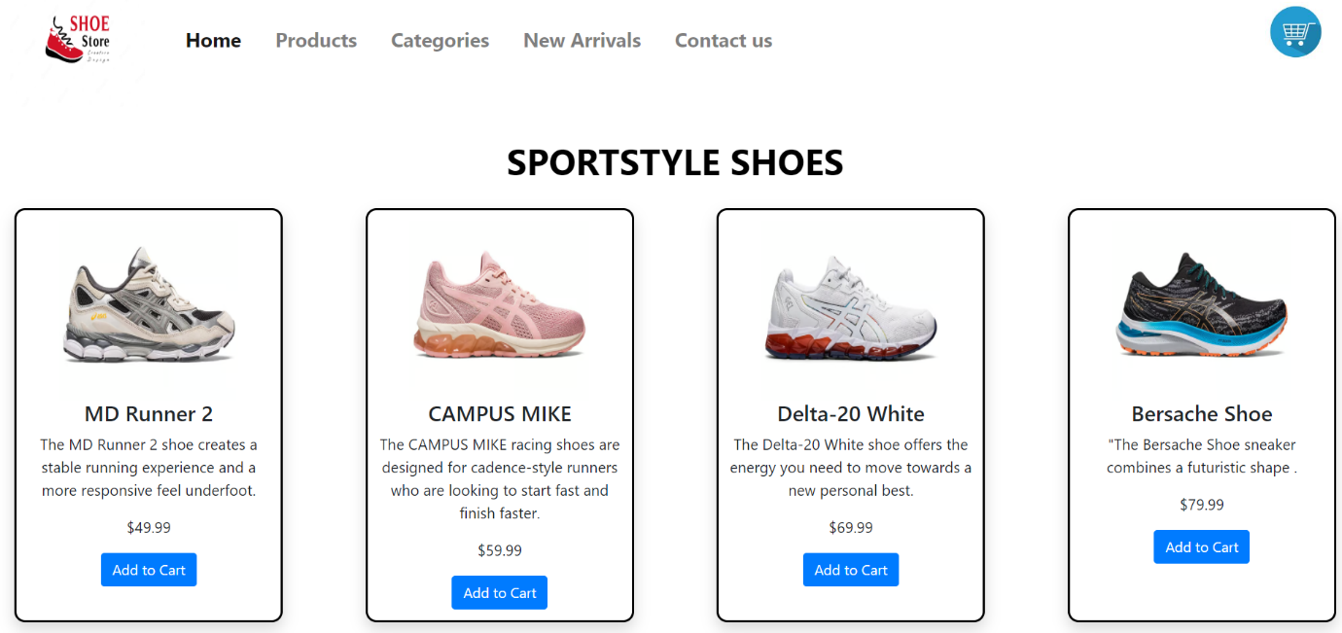

**CHAPTER-5: - ADVANTAGES & DISADVANTAGES**

**Advantages:**

**Global Accessibility:** Customers from different geographical locations can access the store 24/7.

**Extensive Choices:** A wide range of shoe styles, sizes, and brands are available in one platform**.**

**Convenient Shopping:** Users can browse and shop at their convenience, avoiding physical store visits.

**Secure Transactions:** Implementation of secure payment gateways ensures the safetyof financial information.

**Disadvantages:**

**Sizing Challenges**: Customers might face difficulties in determining accurate shoe sizes without trying them on.

**Shipping Delays:** Delivery timelines might vary, leading to potential delays in receiving orders.

**Quality Perception**: Customers might be concerned about the perceived quality of products when shopping online.

**CHAPTER-6: - APPLICATIONS**

The Ecommerce Shoe Store Website solution finds applications in various domains:

**Fashion Retail:** The platform can be expanded to offer a wider range of fashion items, creating a comprehensive online fashion store.

**Marketplace Platforms**: The website's architecture can serve as a foundation for diverse marketplace platforms, hosting multiple sellers and products.

**Global Ecommerce:** The solution aligns with the growing trend of global ecommerce, catering to customers worldwide.

**Niche Footwear Boutiques**: The platform's flexibility allows it to cater to niche footwear markets, such as eco-friendly shoes, specialty sports footwear, and luxury designer brands.

**Corporate Gifting:** Businesses can utilize the website to order branded footwear for employees or clients, streamlining the procurement process.

**Footwear Rental Services**: The platform can be adapted to support footwear rental services for special occasions, reducing the need for customers to buy shoes they'll wear infrequently.

**Charitable Initiatives**: The website can partner with charitable organizations, enabling customers to purchase shoes for donation to those in need.

**CHAPTER-7: - CONCLUSION**

In conclusion, the Ecommerce Shoe Store Website project successfully achieves its goal of providing a seamless online shoe shopping experience. By integrating advanced features, detailed product information, and secure payment gateways, the website enhances convenience and customer satisfaction. This project lays the groundwork for future developments in the field of ecommerce. The Ecommerce Shoe Store Website stands as a testament to technological innovation in the realm of retail. This project's journey from conceptualization to implementation underscores the power of merging user-centric design, secure payment systems, and comprehensive product information to create a digital shopping experience that rivals traditional methods. By addressing customer concerns and enhancing convenience, the website not only transforms the way shoes are purchased but also sets a precedent for the future of ecommerce.

The collaborative effort of designing an intuitive user interface, integrating secure backend systems, and focusing on user engagement has culminated in a platform that caters to a diverse range of customers. Through the challenges faced and overcome during this project, it becomes evident that the digital space holds immense potential for reshaping consumer behaviours and expectations.

**CHAPTER-8: - FUTURE SCOPE**

The project's future scope is rich with potential enhancements:

**Personalization**: Implement AI-driven algorithms to offer personalized product recommendations based on user preferences and browsing history.

**Augmented Reality:** Integrate augmented reality technology to allow customers to virtually try on shoes, enhancing the online shopping experience.

**Mobile Application**: Develop a dedicated mobile app to extend the shopping experience to smartphones, promoting on-the-go purchases.

**Expanded Categories:** Incorporate additional product categories beyond shoes, such as accessories and apparel, to diversify the product offering.

This documentation encapsulates the design, development, and prospects of the Ecommerce Shoe Store Website, serving as a testament to its contribution to the evolving landscape of online retail.